Association Annual Dinner
Guest Speaker
Lord Howard of Lympne
After a three-year hiatus due to the pandemic, Llanelli Boys Grammar School and Graig Former Pupils Association will once more be holding an annual dinner.
This year it will be held at The Diplomat Hotel on Friday October 7th , the guest speaker will be Lord Howard of Lympne. (Michael Howard 1952-1959), many of you will remember his mother’s dress shop (Howard’s in Cowell Street). Lord Howard was the guest speaker at our famous centenary dinner in 2011.
Michael’s career is very distinguished having been Home Secretary and Leader of the Conservative party in opposition. He is outspoken on many controversial subjects and will give his views on the political state of play in October.
Michael said “ I always look forward to visiting Llanelli and meeting former school colleagues. I have so many fond memories of the school and town “
Here is Michael, second from the right seated and chairman of the sixth form forum in 1958.
.
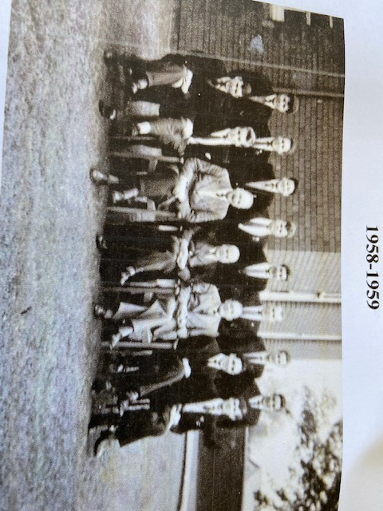
We hope to have a bumper turnout this year, tickets are available from the secretary at secretary@llanelliboysgrammar.org and are priced at £35. Rooms are available at the Diplomat for those who wish to stay overnight. Any organisation or individual interested in taking a table (of eight) should contact the secretary by email.

